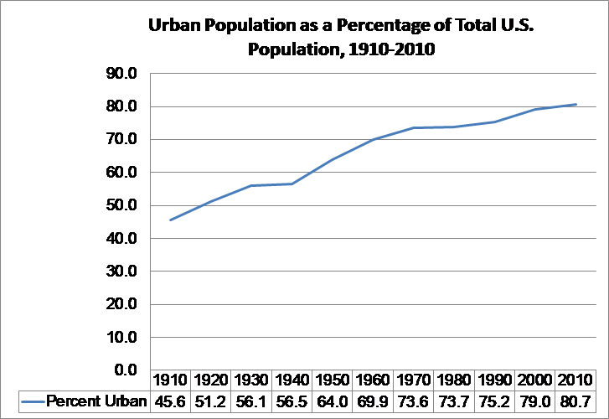

1. What trend does this graph illustrate?