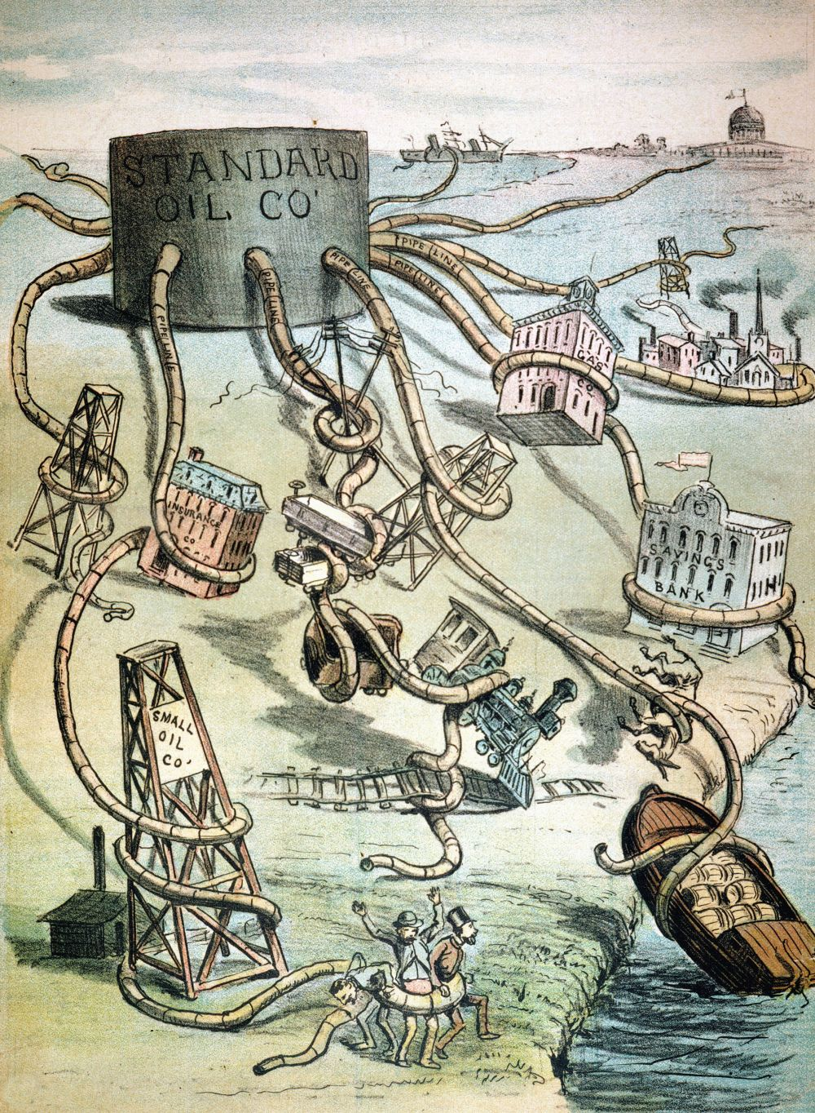
- What is the cartoonist saying about Standard Oil?
- What type of company was it becoming?

