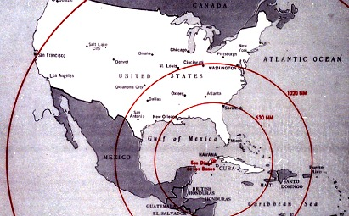

- Why was the U.S. so concerned over the placement of Soviet missiles in Cuba?

