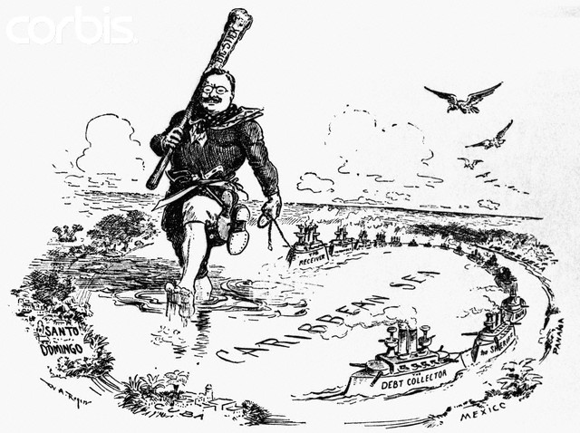

- Who is portrayed in this political cartoon?
- What foreign policy does this cartoon display?
- What area of the world did the U.S. apply this policy to?

