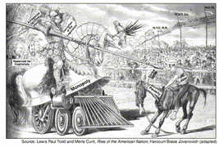

What is the main idea of this cartoon from the 1800s?
- Business has advantages over labor.
- Labor is gaining power over big business.
- Most Americans support the labor movement.
- Government should support the expansion of railroads.

The American Federation of Labor responded to the situation shown in the cartoon by
- forming worker-owned businesses
- organizing skilled workers into unions
- creating a single union of workers and farmers
- encouraging open immigration

