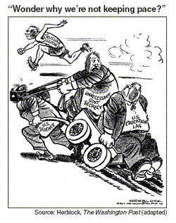

Which event of the 1950s most likely led to the publication of this cartoon?
- The United States was defeated in the Vietnam War.
- American students scored low on tests in math and science.
- Russia put cosmonauts on the Moon.
- The Soviet Union launched the Sputnik satellite.

