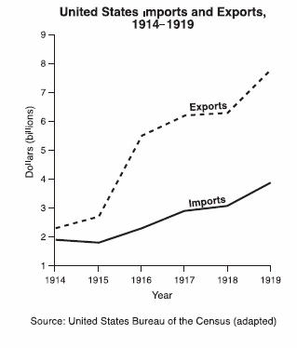

Data from this graph support the conclusion that World War I
A) caused the United States trade deficit to increase
B) cost the United States many billions of dollars
C) was a significant benefit to the American economy
D) created an unfavorable balance of trade

