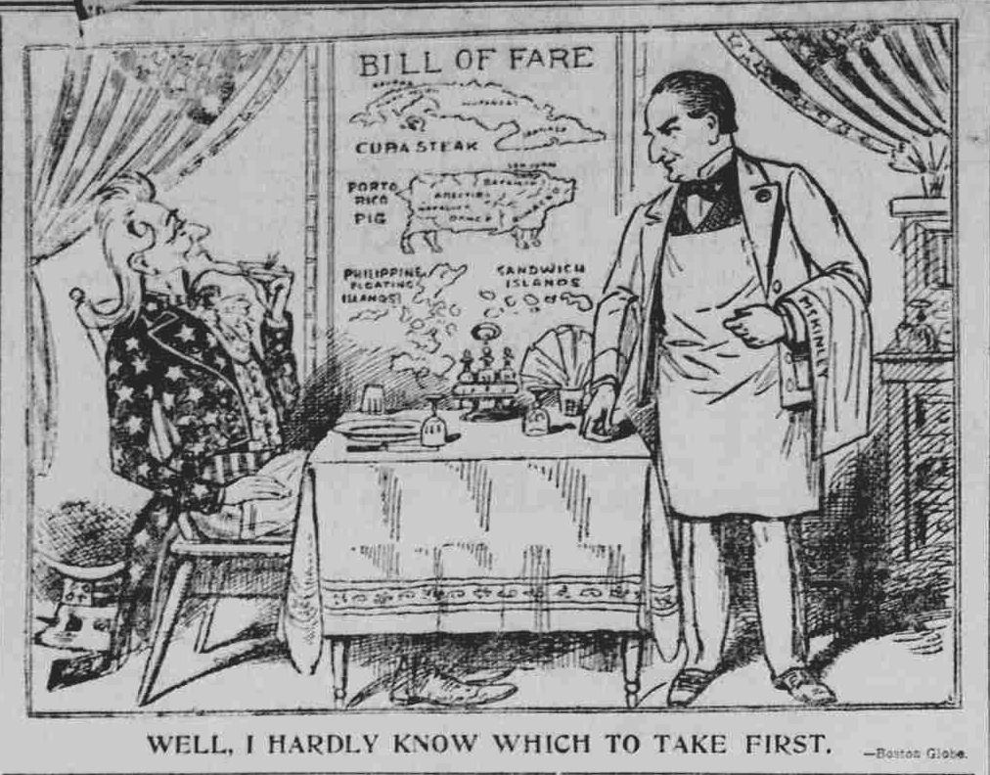

3. During which war was this cartoon created?
4. What was it criticizing?

